Replace **<your-name>** with your **name** throughout the Lab.

1. SSH to the **haproxyVM on Azure or any of the master NODE** of the 3 AWS Clusters.

|  |
| --- |
| $ sudo su  # vim java-app-<your-name>.yaml |

2. **Paste the below script in the java_app.yaml**

Update the image: **lovescloud/java-docker:latest** and replace <yourname> with your namein the below script with your dockerhub image name that you uploaded to docker hub in docker lab Pushing images to docker Hub for java-app.

|  |
| --- |
| apiVersion: apps/v1  kind: Deployment  metadata:  name: java-app-<your-name>  spec:  selector:  matchLabels:  run: java-app-<your-name>  replicas: 2  template:  metadata:  labels:  run: java-app-<your-name>  spec:  containers:  - name: java-app-<your-name>  image: lovescloud/java-docker:latest  ports:  - name: port8080  containerPort: 8080  ---  apiVersion: v1  kind: Service  metadata:  name: java-app-<your-name>  labels:  run: java-app-<your-name>  spec:  type: NodePort  ports:  - name: port8080  port: 8080  protocol: TCP  selector:  run: java-app-<your-name> |

**Save and exit by pressing the ESC key and type wq to save and quit by pressing enter**

3. Run the below commands to deloy the JAVA application on your Kubernetes Cluster

|  |
| --- |
| # kubectl apply -f java-app-<your-name>.yaml |

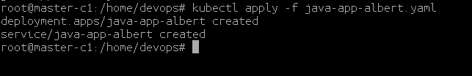

4. Check the **NODE** where your app has been deployed.

|  |
| --- |
| # kubectl get po -o wide |



5. Check the NODEPORT on which the application has been exposed

|  |
| --- |
| # kubectl get svc |

**Example**

**I**n this example the java application has been exposed on port 30900 as shown in the below.

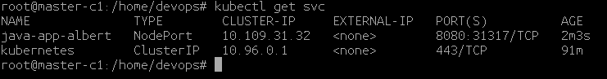

In this example the app has been deployed to the NODE **worker-1 and master-3**

6. Login to the **Azure/AWS** portal and check the public IP of the NODE ( ex worker-1) or (worker1-c1) access the java application web page from the NODE Public IP address and Node Port on which it is exposed at.

**http://<NODE-PUBLIC-IP>:NODEPORT**

Example.

[http://104.211.176.230:31317/](http://104.211.176.230:30900/)

